INTERNSHIP REPORT
AI & ML Internship

Task 4: Feature Encoding & Feature Scaling on Customer Churn Dataset

Student Name: MODI DHRUV BHAVESHBHAI
Internship Track: Artificial Intelligence & Machine Learning
Task Number: Task 4

Dataset Used: Churn_Modelling.csv

Date of Submission: May 29, 2026

Table of Contents

- Introduction
- Objective of the Task
- Dataset Description
- Data Preprocessing Steps
- Feature Encoding
  - What is Feature Encoding?
  - One-Hot Encoding
  - The Dummy Variable Trap

- Feature Scaling
  - Why Scaling is Necessary
  - Standardization (Z-Score Normalization)
  - Normalization (Min-Max Scaling)

- Data Visualization & Observations
  - Histograms Before and After Scaling
  - Boxplots Before and After Scaling

- Results and Observations
- Interview Questions and Answers
- Challenges Faced
- Conclusion
- References

Introduction

Introduction to Data Preprocessing

In the domain of Artificial Intelligence and Machine Learning (AI & ML), the quality of data often holds more significance than the complexity of the algorithm applied. Real-world datasets, such as customer records from a bank, are frequently incomplete, inconsistent, and contain attributes recorded in varying scales and formats. Data preprocessing acts as the critical bridge connecting raw, unstructured data to a format that ML algorithms can effectively consume. This step encompasses cleaning the data, dealing with missing values, identifying outliers, and crucially, transforming features into a uniform numeric space.

Importance of Feature Encoding

Machine learning models are essentially mathematical engines; they compute equations using linear algebra, calculus, and probability. Therefore, they require numerical input matrices. However, business datasets naturally contain categorical text data—such as a customer's location (France, Spain) or gender (Male, Female). Feature encoding is the indispensable process of converting these text-based categories into numeric formats without losing the inherent information, enabling algorithms to detect patterns across demographic or nominal segments.

Importance of Feature Scaling

Features in a dataset rarely share the same scale. For example, in a banking dataset, a customer's Age might range from 18 to 90, while their Balance might range from 0 to 250,000. If left unscaled, distance-based algorithms (like K-Nearest Neighbors or Support Vector Machines) and optimization algorithms (like Gradient Descent used in Neural Networks) will disproportionately weigh the Balance feature merely because its absolute magnitude is exponentially larger. Feature scaling rectifies this by standardizing or normalizing all features to a common scale, ensuring democratic contribution from every variable.

Role of Preprocessing in Machine Learning

Without rigorous preprocessing, ML models suffer from poor convergence, high bias, and misleading evaluation metrics—a phenomenon often referred to as "Garbage In, Garbage Out". Preprocessing ensures numerical stability, expedites model training times, and prevents the algorithm from memorizing meaningless identifiers (like row indices or names), forcing it to focus purely on generalized, predictive patterns.

Objective of the Task

The primary objectives of Internship Task 4 are structured to impart hands-on experience in feature transformation techniques. The specific objectives include:
- Convert categorical data into numerical form: Transforming text columns into machine-readable numeric arrays.
- Apply encoding techniques: Specifically implementing One-Hot Encoding on nominal features.
- Apply scaling techniques: Standardizing and normalizing the continuous numerical variables to uniform scales.
- Compare data before and after scaling: Utilizing Python visualization libraries to observe and document the distributional and range changes occurring due to transformations.

Dataset Description

The practical implementation for this task is conducted on the Churn_Modelling.csv dataset. This dataset simulates the customer records of a European bank, aiming to predict customer churn (i.e., whether a customer will close their account and leave the bank).
Overview: The dataset comprises 10,000 rows (customer records) and 14 columns (attributes).

Feature Dictionary

Feature Name | Data Type | Description
RowNumber | Integer | Sequential index of the record (irrelevant for ML).
CustomerId | Integer | Unique identifier for the bank client.
Surname | String | Last name of the customer (irrelevant for generalized ML).
CreditScore | Integer | Numerical score reflecting the customer's creditworthiness.
Geography | Categorical | The country of the customer (France, Spain, Germany).
Gender | Categorical | The gender of the customer (Male, Female).
Age | Integer | Age of the customer in years.
Tenure | Integer | Number of years the customer has been with the bank.
Balance | Float | Account balance of the customer.
NumOfProducts | Integer | Number of bank products the customer uses (e.g., loans, credit cards).
HasCrCard | Binary (0/1) | Indicates whether the customer possesses a credit card.
IsActiveMember

 | Binary (0/1) | Indicates whether the customer is considered an active member.
EstimatedSalary | Float | The estimated annual salary of the customer.
Exited | Binary (0/1) | Target Variable: 1 if the customer churned, 0 otherwise.

Data Preprocessing Steps

Step 1: Loading the Dataset

The initial step involves importing the raw CSV file into a structured DataFrame. The Pandas library in Python is the industry standard for this operation, providing highly efficient data manipulation capabilities.

import pandas as pd import numpy as np

# Load the dataset
df = pd.read_csv('Churn_Modelling.csv')

# Display the first five rows print(df.head())

Step 2: Removing Unnecessary Columns

Not all columns possess predictive power. Columns like RowNumber, CustomerId, and Surname are unique identifiers or administrative metadata. If fed into a machine learning model, the model might attempt to find false patterns (e.g., memorizing specific surnames) which leads to severe overfitting. Thus, they must be discarded.

# Drop columns that have no impact on customer churn df.drop(['RowNumber', 'CustomerId', 'Surname'], axis=1, inplace=True)

Step 3: Identifying Categorical and Numerical Features

After cleaning, we must partition the columns. Numerical features contain continuous or discrete numeric values with mathematical meaning (e.g., Age, Balance). Categorical features represent

text-based groups or categories (e.g., Geography, Gender). Identifying these is critical because different preprocessing techniques apply to each type.

Feature Encoding

What is Feature Encoding?

Feature encoding is a fundamental transformation process that converts categorical variables (text strings) into numerical representations. As discussed, ML models (like Logistic Regression or Random Forests) compute weights based on numerical inputs. They cannot multiply a weight by a string like "France". Therefore, encoding is a mandatory step before model training.

One-Hot Encoding

For nominal data (categories without a mathematical order or rank), such as Geography and Gender, Label Encoding (assigning 0, 1, 2) is dangerous because the algorithm might interpret a false hierarchy (e.g., Germany (2) > France (0)).
One-Hot Encoding solves this by creating a new binary column for each unique category. A value of 1 indicates the presence of the category, while 0 indicates its absence.

Example: Encoding the 'Gender' Column

Original column:

Gender
Male
Female

After One-Hot Encoding:

Gender_Female | Gender_Male
0 | 1
1 | 0

# Applying One-Hot Encoding using Pandas
df = pd.get_dummies(df, columns=['Geography', 'Gender'], drop_first=True)

The Dummy Variable Trap

The "Dummy Variable Trap" is a scenario where the newly created dummy variables are highly correlated (multicollinear). For example, if we have Gender_Male and Gender_Female, we can perfectly predict one from the other: Gender_Female = 1 − Gender_Male. This multicollinearity confuses algorithms like Multiple Linear Regression, making matrix inversion unstable or impossible.
Solution: We solve this by dropping one of the dummy columns (using drop_first=True in pandas). If we have n categories, we only need n − 1 dummy variables to represent them perfectly.

Feature Scaling

Why Scaling is Necessary

Feature scaling addresses the disparity in numerical magnitudes across different columns. If the EstimatedSalary ranges up to 200,000, and Tenure only goes up to 10, any algorithm that computes Euclidean distance (like K-Means clustering or K-Nearest Neighbors) will be entirely dominated by the salary feature. The model will practically ignore the tenure. Scaling forces all numerical features into a comparable range.
For this task, the continuous numerical features requiring scaling are: CreditScore, Age, Tenure, Balance, NumOfProducts, and EstimatedSalary.

Standardization (Z-Score Normalization)

Standardization rescales the features such that they exhibit the properties of a standard normal distribution. After standardization, the feature will have a Mean (μ) = 0 and a Standard Deviation (σ) = 1.

Z = (X − μ) / σ

Purpose & Advantages: Standardization is highly robust to outliers compared to Min-Max scaling. It does not force data into a strict bounding box, preserving the variance and shape of the original distribution. It is the preferred choice for algorithms assuming a Gaussian distribution, such as Support Vector Machines (SVM) and Principal Component Analysis (PCA).

from sklearn.preprocessing import StandardScaler scaler_std = StandardScaler()
df_standardized = scaler_std.fit_transform(df[numerical_cols])

Normalization (Min-Max Scaling)

Normalization scales the data strictly within a predefined fixed range, usually between 0 and 1.

Xnorm = (X − Xmin) / (Xmax − Xmin)

Purpose & Advantages: Normalization is beneficial when the exact bounds of the data are known and when the algorithm requires inputs to be bounded (e.g., Image processing pixel intensities, or activation functions in deep neural networks like Sigmoid). However, it is highly sensitive to outliers—a single extreme outlier can crush the rest of the data into a tiny numerical sliver.

Data Visualization & Observations

To tangibly observe the effects of scaling, we utilize histograms (to view distribution shape) and boxplots (to view scale ranges and outliers) generated using Matplotlib and Seaborn.

Histograms Before and After Scaling

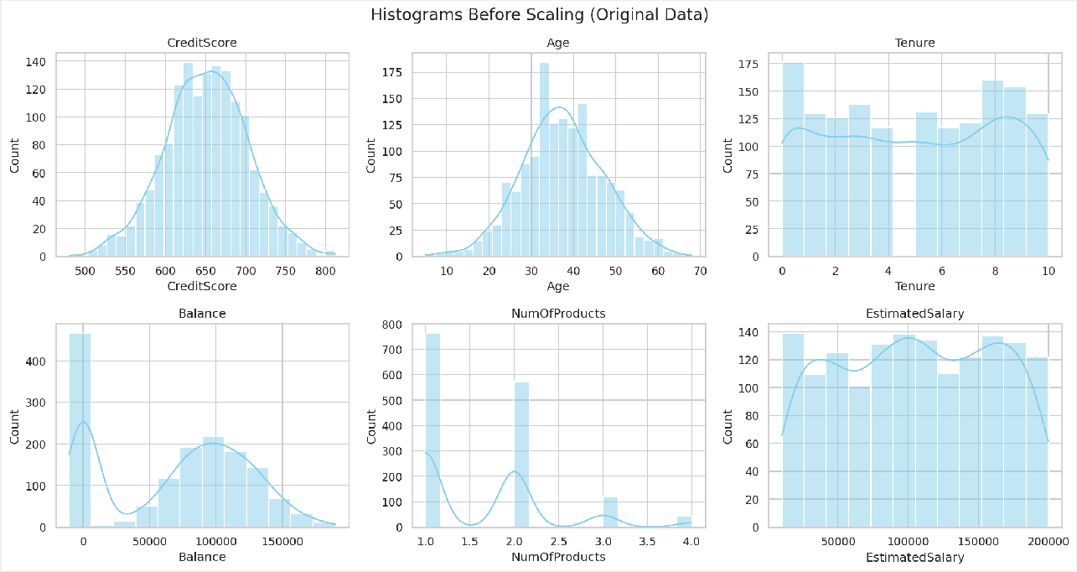
Figure 1: Distribution of numerical features before any scaling is applied. Note the vastly different x-axis scales (e.g., Balance vs. Tenure).

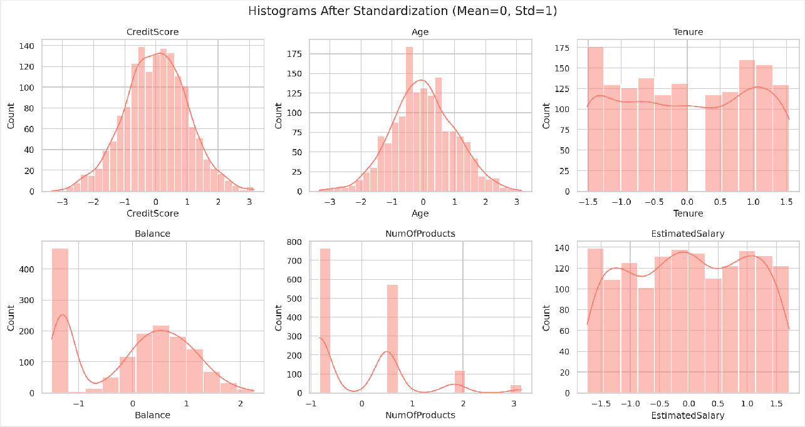

Figure 2: Distribution after Standardization. The x-axis is centered around 0.

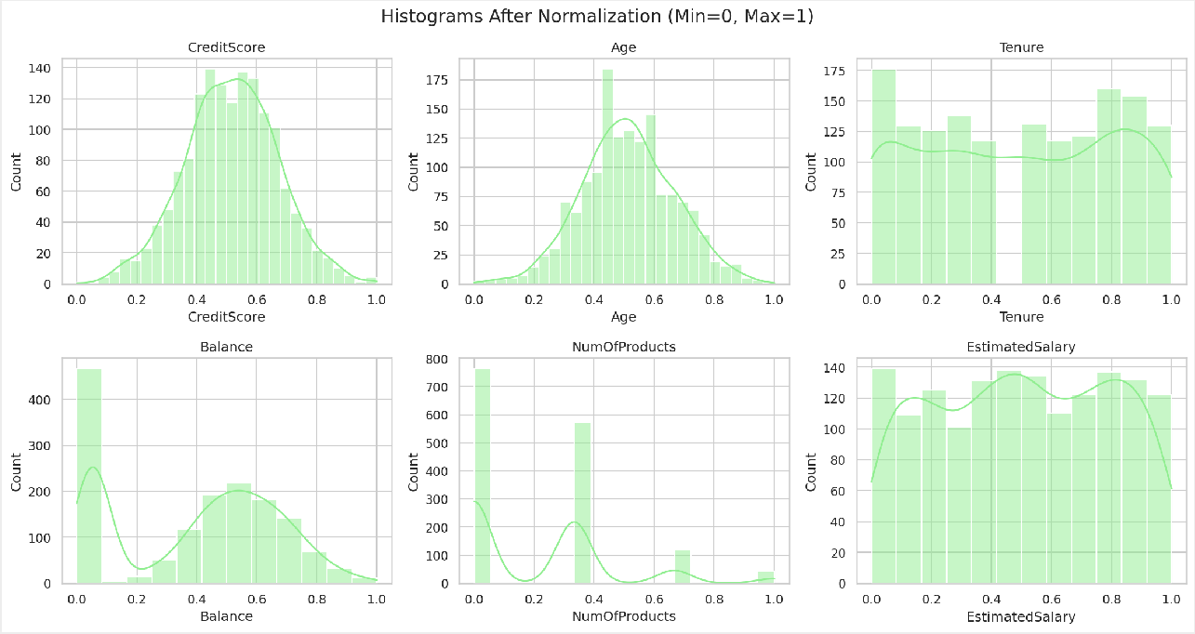

Figure 3: Distribution after Min-Max Normalization. The x-axis is strictly bound between 0.0 and 1.0.

Observation on Histograms: The underlying "shape" (skewness, multimodality) of the data distribution does not change. Whether looking at the original data or the scaled data, the peaks and valleys remain identical. What changes is exclusively the labels on the x-axis. Standardization shifts the center of mass to zero, while Normalization squashes the entire distribution into a [0,1] window.

Boxplots Before and After Scaling

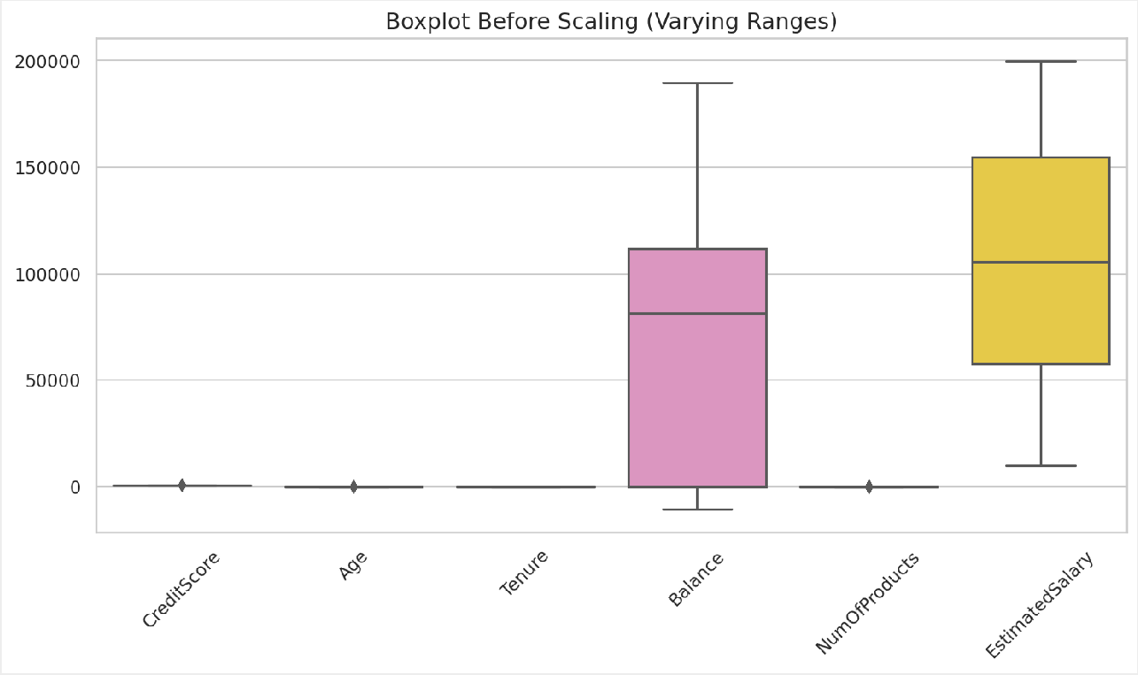
Figure 4: Boxplot of original features. Notice how Balance and EstimatedSalary completely compress the other variables, rendering them invisible.
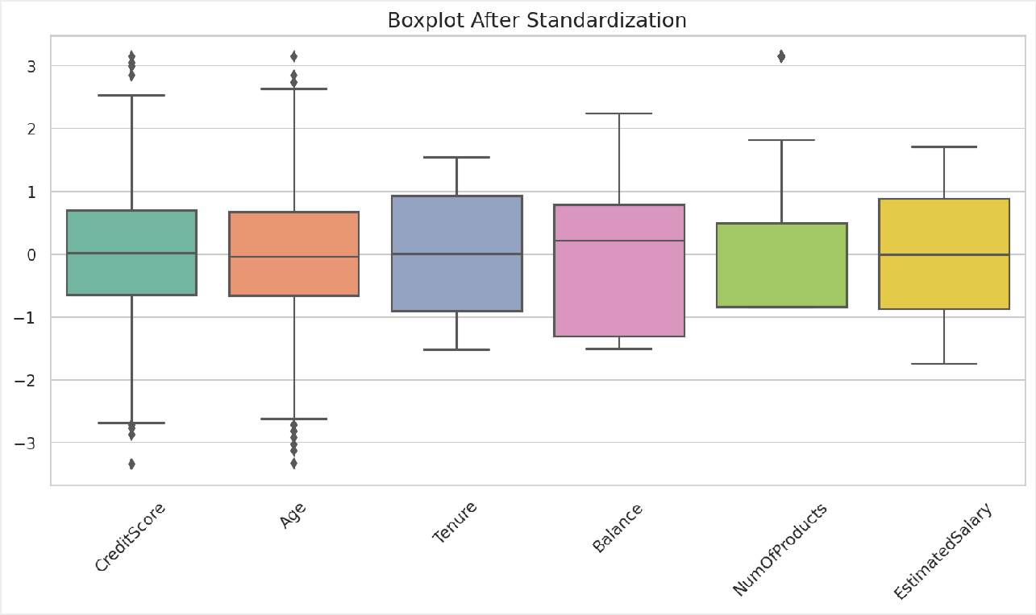

Figure 5: Boxplot after Standardization. Features are clearly comparable, with their medians aligning near 0.

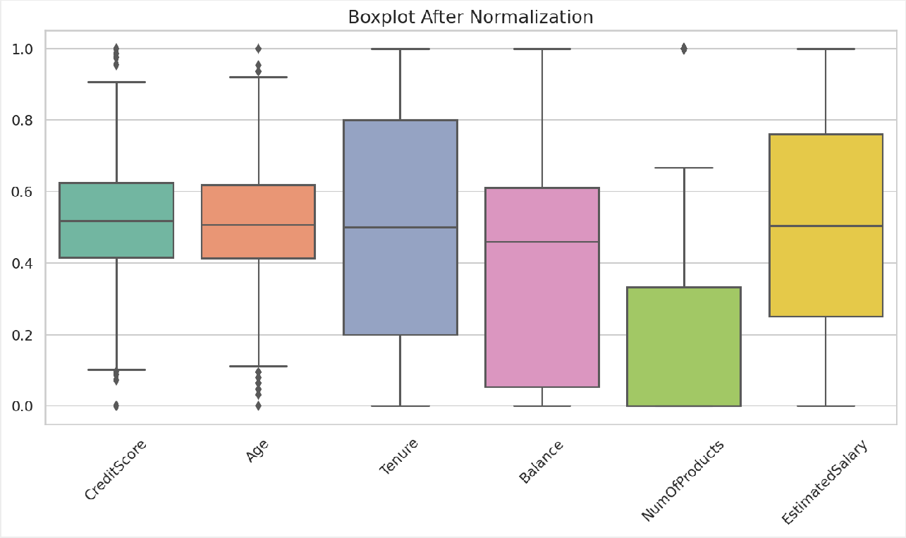

Figure 6: Boxplot after Normalization. All features are strictly contained within the 0 to 1 boundaries.

Observation on Boxplots: The unscaled boxplot visually proves why scaling is necessary; features with smaller magnitude (like Age or Tenure) look like a flat line at 0 because the y-axis is forced to accommodate ranges up to 250,000 for Balance. After applying Standardization or Normalization, every feature's distribution, median, interquartile range, and outliers become visually distinct and mathematically comparable, ensuring no single feature dominates the ML model.

Results and Observations

A direct comparison of the dataset states yields the following critical observations:

- Original Data: Contains raw variance. The algorithm is heavily biased toward
EstimatedSalary and Balance. Categorical data is unreadable by algebraic models.
- Encoded Data: Nominal text formats are successfully expanded into dense binary matrices without ordinal bias, satisfying mathematical constraints.
- Standardized Data: Features exhibit μ = 0 and σ = 1. Outliers are preserved but scaled down proportionally. This dataset state is optimal for the majority of standard ML models.
- Normalized Data: Features are squashed into the [0, 1] boundary. This dataset state is useful primarily if we plan to feed the data into a dense Neural Network relying on strictly bounded activation functions.

Interview Questions and Answers

Q1. Difference between Label Encoding and One-Hot Encoding?
Label Encoding assigns a unique integer to each category (e.g., Red=1, Blue=2, Green=3). It is efficient but introduces a false mathematical hierarchy, which is problematic for linear models. One-Hot Encoding creates a separate binary column for each category, completely removing ordinal assumptions. It is preferred for nominal data but can lead to high dimensionality.
Q2. When should Standardization be used?
Standardization is highly recommended when the dataset contains significant outliers, as it is less sensitive to extreme values compared to Min-Max scaling. It is strictly required for algorithms that assume features are centered around zero and have similar variance, such as Principal Component Analysis (PCA), Ridge/Lasso Regression, and Support Vector Machines.
Q3. When should Normalization be used?
Normalization should be employed when you require the data to be strictly bounded within a specific scale (usually 0 to 1). It is commonly used in image processing (scaling pixel intensities), K-Nearest Neighbors (when bounds are fixed), and in Deep Learning frameworks where bounded inputs help activation functions (like Sigmoid) avoid saturation.
Q4. What is the Dummy Variable Trap?
It is a scenario of perfect multicollinearity occurring after One-Hot Encoding, where one dummy variable can be perfectly predicted from the others. This redundancy causes the design matrix to become non-invertible, breaking algorithms like Ordinary Least Squares (OLS) regression. We avoid it by dropping one category per encoded feature.
Q5. Why do KNN and K-Means require scaling?
Both K-Nearest Neighbors and K-Means clustering rely fundamentally on distance metrics (such as Euclidean or Manhattan distance) to evaluate the similarity between data points. If features operate on vastly different scales (e.g., Age in tens vs. Salary in thousands), the algorithm will compute distance almost entirely based on the larger scale, effectively ignoring the smaller scale feature.
Q6. Can One-Hot Encoding be applied to high-cardinality features?
While theoretically possible, applying One-Hot Encoding to high-cardinality features (like Zip Codes or User IDs) is heavily discouraged. It results in the "Curse of Dimensionality," producing

massive, sparse matrices that consume excessive memory and lead to severe model overfitting. For such features, target encoding or embeddings are preferred.
Q7. What are the advantages of feature scaling?
Feature scaling drastically improves the convergence speed of optimization algorithms like Gradient Descent. It prevents features with broad ranges from improperly dominating distance calculations. It also enhances numerical stability during complex matrix operations, ensuring floating-point calculations do not overflow or lose precision.
Q8. Which algorithms are sensitive to feature scales?
Distance-based algorithms (KNN, K-Means, SVM), optimization-based algorithms utilizing Gradient Descent (Linear/Logistic Regression, Neural Networks), and variance-based algorithms (PCA) are highly sensitive to scales. Tree-based algorithms (Decision Trees, Random Forests, XGBoost) are naturally scale-invariant and generally do not require scaling.

Challenges Faced

During the execution of this task, several practical and analytical challenges were encountered and resolved:
- Choosing the Correct Scaler: Analyzing the difference between standardization and normalization required deep statistical consideration. Dealing with the Balance feature (which contains many zeros but also high positive values) highlighted the fact that Min-Max scaling would compress the non-zero variance tightly. Standardization proved more robust.
- Interpreting Visual Output: Generating boxplots for the unscaled data initially yielded a graph where smaller features were entirely invisible. Adjusting visualization strategies to graph the scaled vs. unscaled data sequentially was required to fully grasp the visual impact.
- Handling the Dummy Trap: Recognizing the mathematical requirement to implement drop_first=True during pandas dummy creation required investigating matrix collinearity concepts that extend beyond simple syntax execution.

Conclusion

In summary, Task 4 thoroughly demonstrated that raw data is rarely in an optimal state for machine learning algorithms. The successful implementation of Feature Encoding effectively translated categorical parameters like Geography and Gender into algebraic logic using One-Hot encoding, cleanly avoiding the dummy variable trap.
Furthermore, applying Standardization and Normalization fundamentally restructured the dataset's topography without altering its underlying narrative or distribution shape. The visual proofs from histograms and boxplots categorically confirmed that scaled features offer a democratized numerical environment, paving the way for unbiased, efficient model training. The completion of this task solidifies a crucial pillar in the data science pipeline: transforming chaotic, multi-scale human data into refined, mathematically sound model inputs.

References

- Scikit-learn Documentation: Preprocessing data (https://scikit-learn.org/stable/modules/ preprocessing.html)
- Pandas Documentation: pandas.get_dummies (https://pandas.pydata.org/docs/reference/api/ pandas.get_dummies.html)
- NumPy Documentation: Mathematical functions (https://numpy.org/doc/)
- Matplotlib & Seaborn Documentation: Data Visualization guidelines.
- Dataset Source: Kaggle Churn_Modelling Dataset (https://www.kaggle.com/code/ adarsh0063/customer-churn-dataset/input)
- Reference Colab URL: Google Colab Runtime

